**Power Analysis Report**

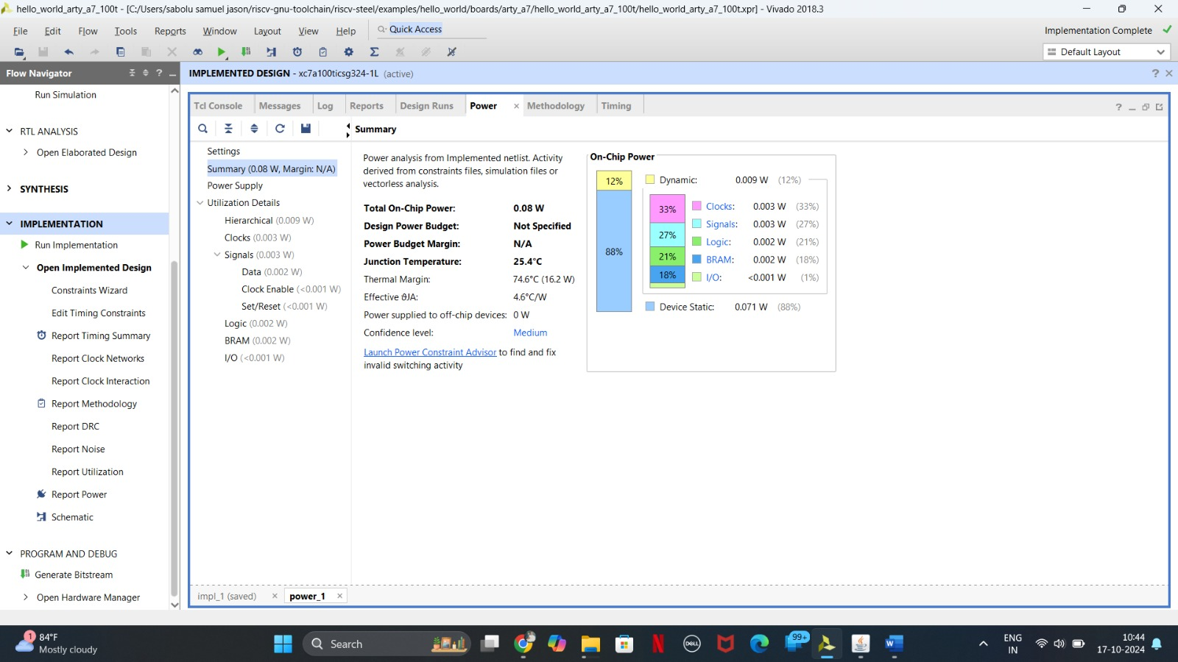

**Summary**

* **Total On-Chip Power:** 0.009 W
* **Dynamic Power:** 0.003 W (33%)
* **Static Power:** 0.006 W (67%)
* **Power Supply:** 3.3 V
* **Junction Temperature:** 25.4 °C
* **Thermal Margin:** 74.6 °C
* **Effective 6JA:** 4.6 °C/W
* **Power supplied to off-chip devices:** 0.071 W (88%)
* **Confidence Level:** Medium

**Power Breakdown**

|  |  |  |
| --- | --- | --- |
| **Component** | **Power Consumption (W)** | **Percentage** |
| Clocks | 0.003 | 33% |
| Signals | 0.003 | 33% |
| Logic | 0.002 | 21% |
| BRAM | 0.002 | 21% |

**Observations and Recommendations**

* **Dominant Power Consumer:** Clocks and Signals are the primary contributors to power consumption, accounting for 66% of the total. Optimizing clock distribution and signal switching activity could significantly reduce power usage.
* **Static Power:** While static power is relatively high, it's important to ensure that the design is optimized for low leakage currents. Techniques like gate sizing and power gating can help reduce static power.
* **Thermal Margin:** The current thermal margin of 74.6 °C is adequate, but it's essential to monitor the junction temperature during operation to avoid overheating.
* **Power supplied to off-chip devices:** A significant portion of the total power is being consumed by off-chip components. If possible, reducing the number or complexity of these components can help lower overall power consumption.

**Additional Considerations:**

* **Power Budgeting:** A power budget should be established to ensure that the design meets specific power constraints.
* **Power Optimization Techniques:** Techniques like clock gating, power gating, and voltage scaling can be employed to further reduce power consumption.
* **Simulation and Verification:** Power analysis should be integrated into the design and verification process to identify potential power-related issues early on.